A picture containing clipart

Description generated with very high confidence

Azure 103 Module 4

Hands On - 9

Azure Certification Training

[**support@intellipaat.com**](mailto:support@intellipaat.com)

**+91-7022374614**

**US: 1-800-216-8930(Toll Free)**

**Azure 103 Module 2 , Hands On – 9**

**Attach or Detach an External Storage Account.**

**Step 1:** Open Storage Account in Azure Portal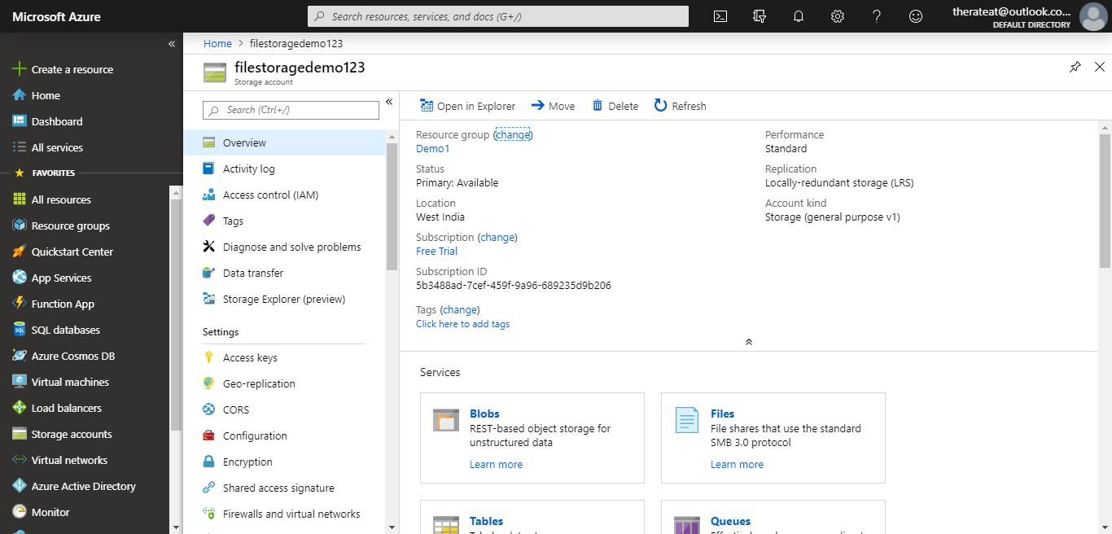

**Step 2:** In the settings section click on access keys.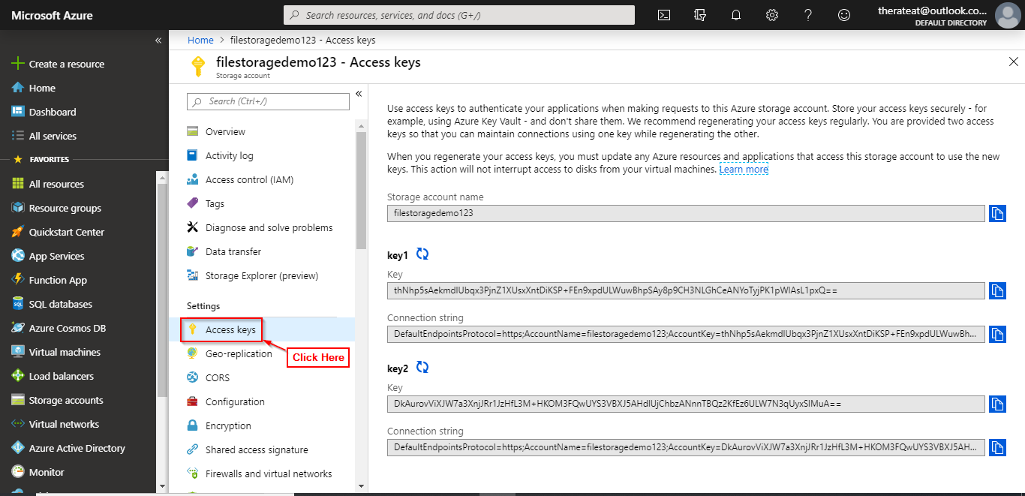

**Step 3:** Copy one of the keys.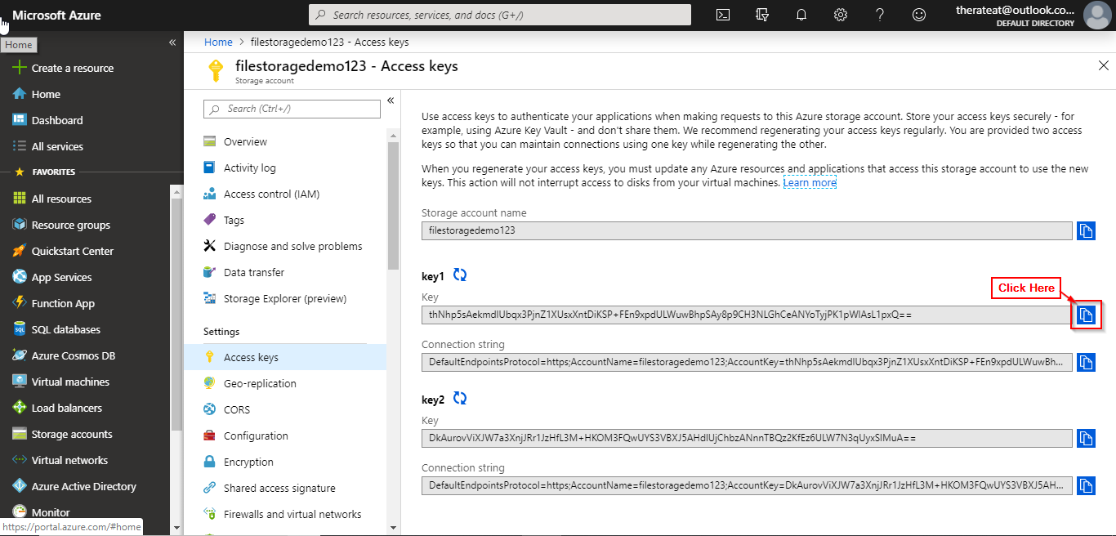

**Step 4:** Open Azure Storage Explorer.

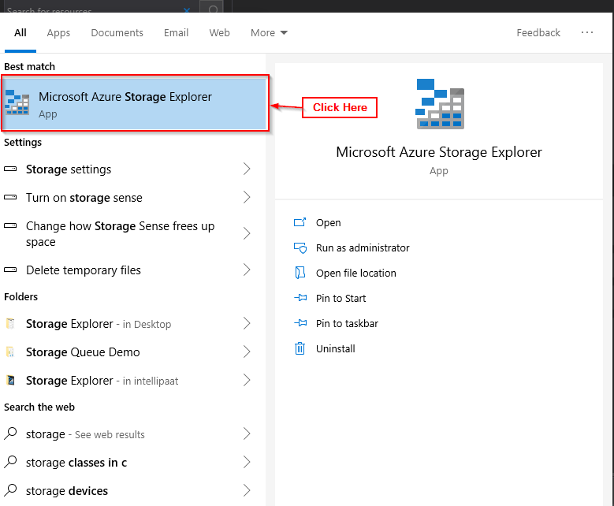

**Step 5:** Click on add account button.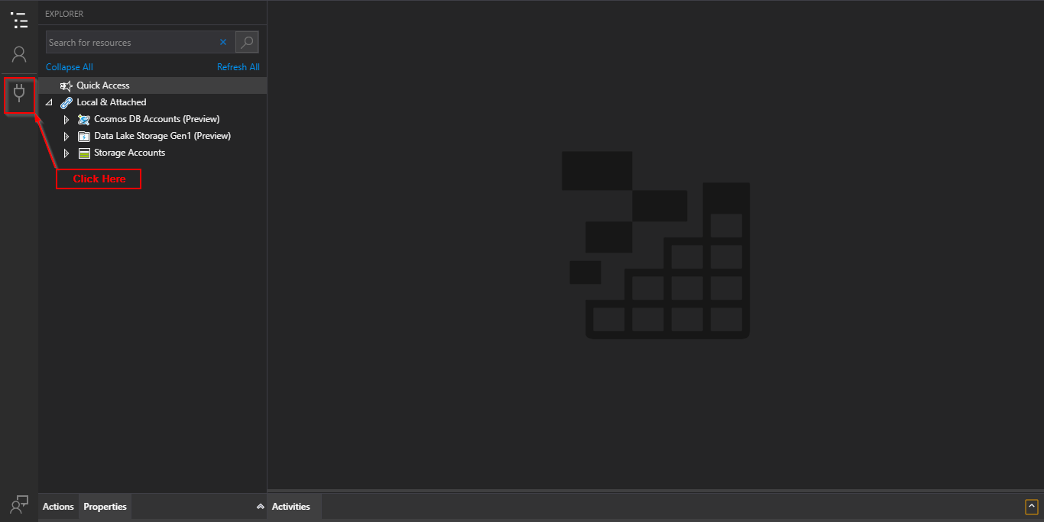

**Step 6:** Select use a storage account name and key and click next.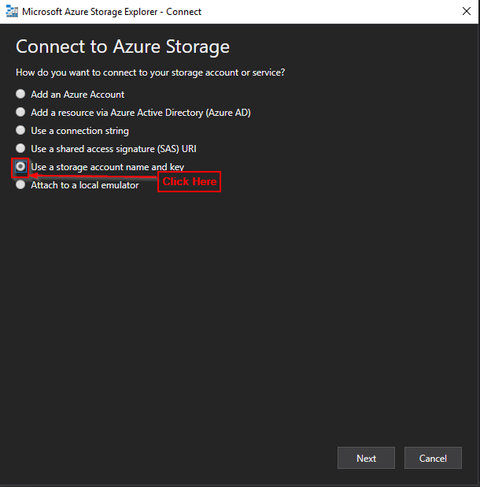

**Step 7:** Enter Display Name, Account Name and Account Key that you copied.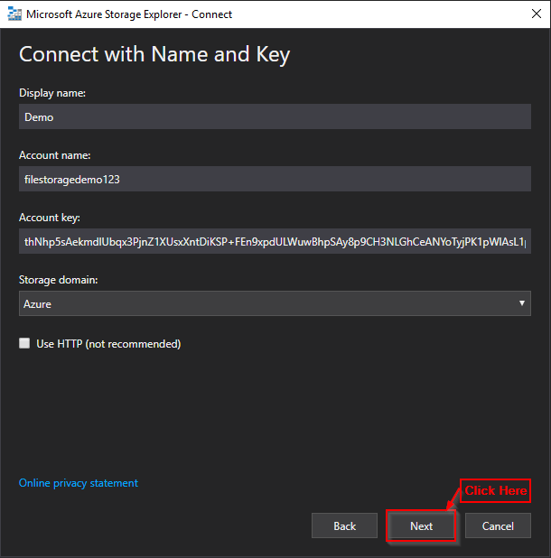

**Step 8:** Click on connect.

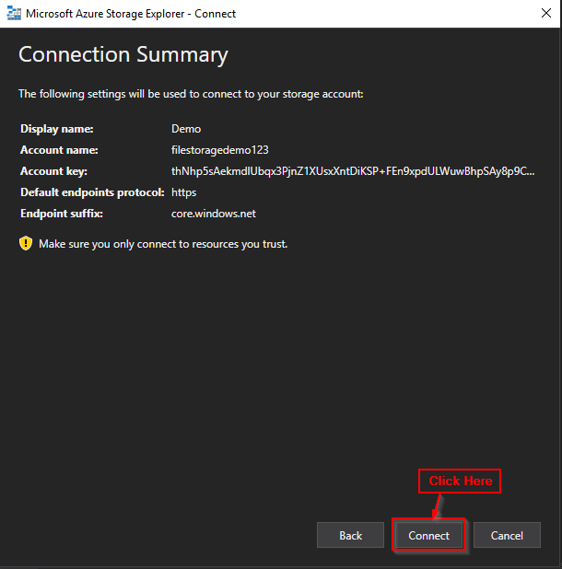

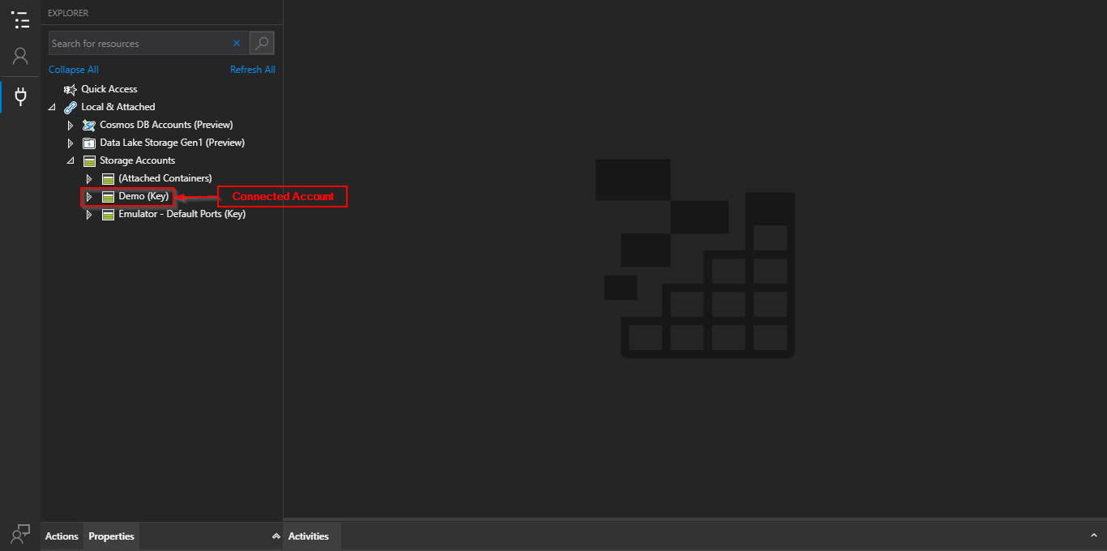

**Detach External Storage Account**

**Step 1** Open Azure Storage Explorer.



**Step 2** In the storage account section right click on the storage account you wish to detach.

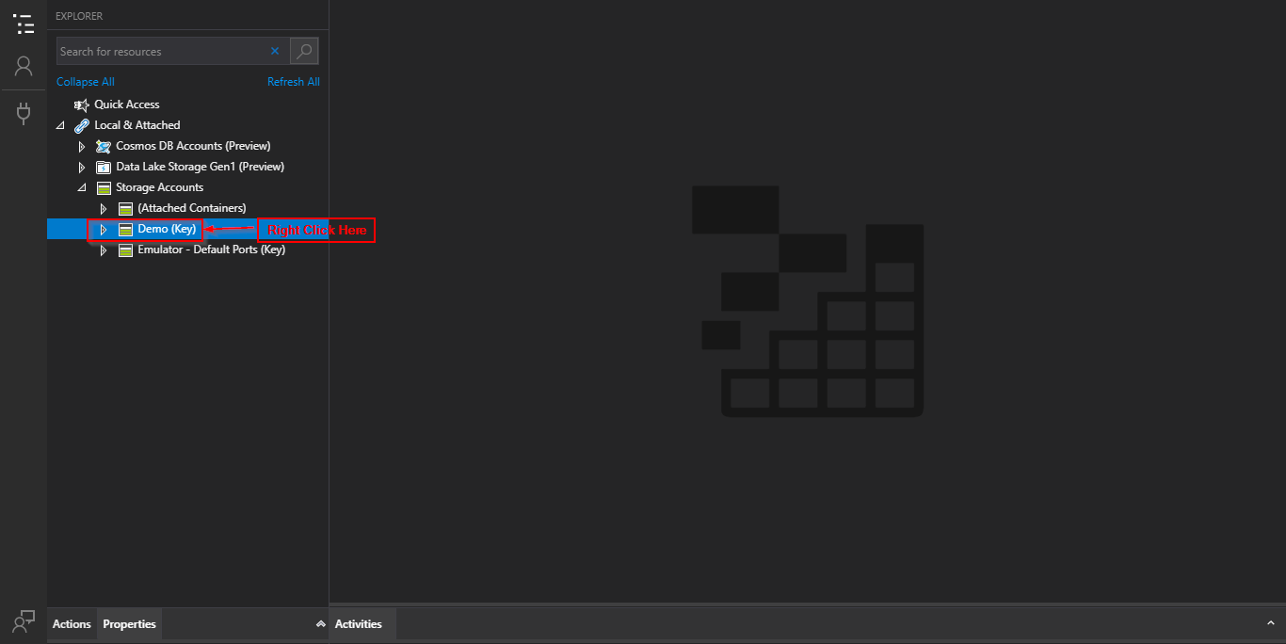

**Step 3** Click on detach.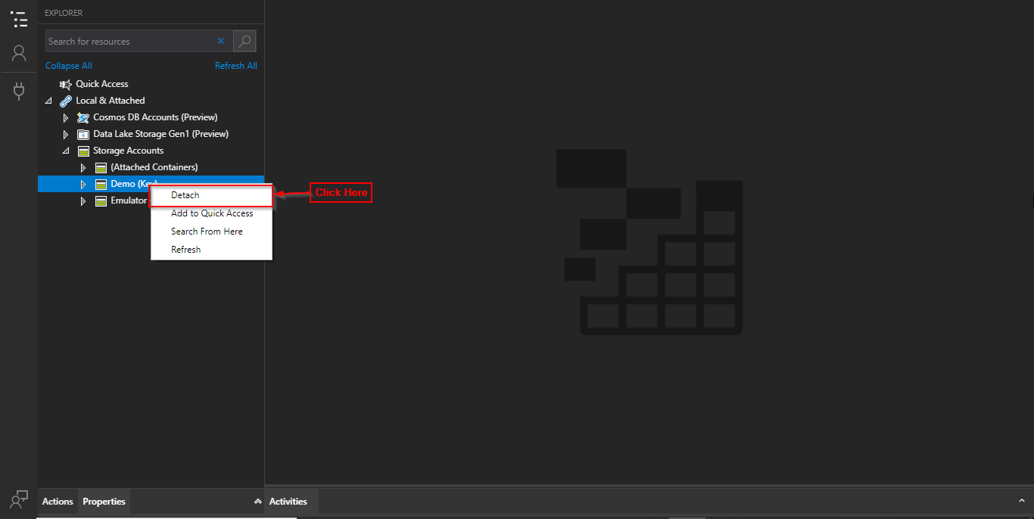

**Step 4** Click on yes.